**Guess the Temperature: Design of Temperature Sensor**

Aayahna Herbert

Chanty Brown, Emma Shirley

1. **Introduction/Specific Aims (1 pages)**

Temperature holds a lot of importance and can affect the outcome of various things in a wide variety of areas. It is used to determine if a person is sick, food is prepared and cooked properly, and experiments are done correctly. Being able to read and tell the difference between multiple temperature measurements is a necessity in today’s society. While we do have temperature readings such as thermometers, it would be pretty impressive and convenient in rare cases to train oneself to know the temperature of something just from a simple touch.

The goal of this project is to allow users to train themselves to detect the temperature of an object just from touching it. The project will let the user enter their guess of the temperature and will tell them if they are correct or if they should guess something hotter or colder relative to the actual temperature of the item. While this is a way to train oneself to guess the temperature accurately, it is also doubles as a fun guessing game to keep someone preoccupied. This design – although its main purpose is a game – could potentially result in the development of a skill that could be used by cooks and chefs, nurses and doctors, and anyone who just wants to be able to tell the temperature of something by a simple touch.

**Specific Aim 1:** To design a system to measure temperature

**Specific Aim 2:** To create a game to teach people to guess temperatures by feel

**Specific Aim 3:** To teach the importance of correct sensor selection and technology advancement for temperature measurements to the public

1. **Background (1 page)**

Three of the most common temperature sensors are thermistors, RTDs, and thermocouples. Thermistors are a type of resistor that’s resistance changes when it experiences temperature changes1. Some of the things that make the thermistor favorable are how quickly it responds to changes in temperature and its accuracy and repeatability. It can go through large amounts of resistance change in degrees Celsius and small temperature change because of its accuracy of 0.05°C to 1.5°C2. A downside to the thermistor is while it does have fantastic accuracy, its temperature range it can operate in is narrow and limited, starting around -100°C and ending at about 300°C, but they’re easy to find and usually sold at an okay price3. Thermistors can either have a negative temperature coefficient of resistance (NTC) – as the temperature increases, the resistance decreases – or a positive temperature coefficient of resistance (PTC) – as the temperature increases, the resistance increases as well – but most of the time the one mostly used is the NTC1. Because it is nonlinear and behaves exponentially, its output voltage needs to be linearized3, which is accomplished by “generally [connecting] in series with a suitable biasing resistor to form a potential divider network and the choice of resistor gives a voltage output at some pre-determined temperature point or value”1. By setting up a voltage divider with the thermistor and some resistor that offsets its own resistor, the current and, therefore, the output voltage will become linear with the temperature.

The second type of temperature sensor is the resistive temperature detector (RTD) which is an electrical resistance temperature sensor that is precise and made from “high-purity conducting metals”1. RTDs could be a hit or miss temperature sensor because in order for it to be the best, more money must be spent, otherwise, it can be unstable and unrepeatable2. When made of platinum (PRT), it considered one of the most stable and accurate temperature sensor with an accuracy of about 0.03 to 0.3°C and a temperature range from -250°C to 850°C, which is not the widest of them all3. Because it is very expensive, the PRT is sometimes passed over for a “lower-cost RTD made from nickel or copper” which are relatively unstable and unable to be repeated2. To avoid self-heating errors and to get the highest accuracy, a four-wire configuration is set up as a Wheatstone Bridge network to bring about extra connecting wires, helping to keep the excitation current low (preferable below 1mA)3. Because of this wiring, it is able to obtain an output voltage that increases linearly with temperature, like the thermistor.

Lastly is the thermocouple, the most commonly used temperature sensor1. Consisting of two wires, both made from differing metals connecting at two points2, it makes it simple, easy to use, and gives it a speedy response time for temperature changes due to its tiny size. It also has one of widest temperature ranges starting at -200°C up to around 2000°C but a low accuracy reading of 0.5 to 5°C. On the bright side, it is self-powered and consequently doesn’t need an excitation current, making wiring simple3. To accurately measure the output voltage, it uses cold junction compensation (CJC), meaning “one wire is kept at a constant temperature (reference cold junction), while the other is the measuring (hot) junction,” causing constantly differing temperatures to get a voltage reading1. One must still avoid sudden temperature changes or will face multiple errors while handling the thermocouple.

1. **Research Methods and Design (2-3 pages)**

To build a temperature sensor guessing game, we will utilize a temperature sensor and user interface through interaction through the display and keypad from the Arduino Keypad Shield. Our group plans on using the following guidelines and design:

**Aim 1: To design a system to measure temperature**

We will set up the main design of measuring temperature by using a thermistor and a resistor connecting to the Arduino UNO. To use the thermistor, there must be a resistor, with a value equal to the resistance of the thermistor, in series with the thermistor to offset its own resistance. The end of the thermistor not connected to the resistor will be connected to the 5V+ power on the Arduino UNO, the end of the resistor not connected to the thermistor will be connected to the ground on the Arduino UNO. For the readings to be processed by Arduino, the node where the thermistor and the resistor meet will be connected to an analog pin on the Arduino UNO. With it now being connected to an analog pin, Arduino will be able to do an analog read with the resistance of the thermistor stripped away that way the temperature can be calculated. If time allots and we finish the circuit ahead of the project presentation, we might create different circuits with various temperature sensors to compare their accuracies and allow the game to use the different sensors as difficulty levels with the difficulty increasing as the accuracy of the temperature sensor increases.

**Aim 2: To create a game to teach people to guess temperatures by feel**

After the circuit for the temperature sensor is working correctly, the Arduino Keypad Shield will be connected to the Arduino UNO as shown in **Figure** 1, displaying how all the materials used for the game are connected to each other. After being connected correct, code will be made and uploaded to the Arduino Keypad LCD Shield, so it is programmed to follow the process shown in the flow chart in **Figure 2**.

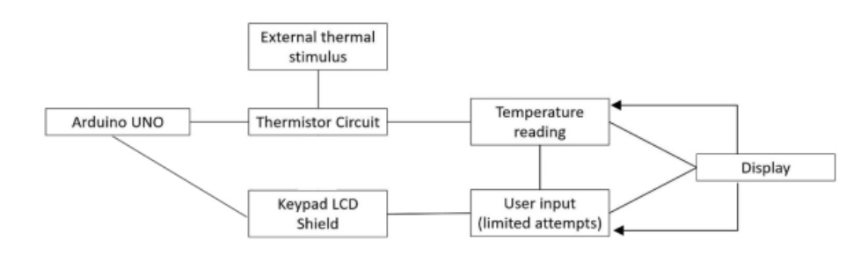

**Figure 1**: Overall Connection Flowchart

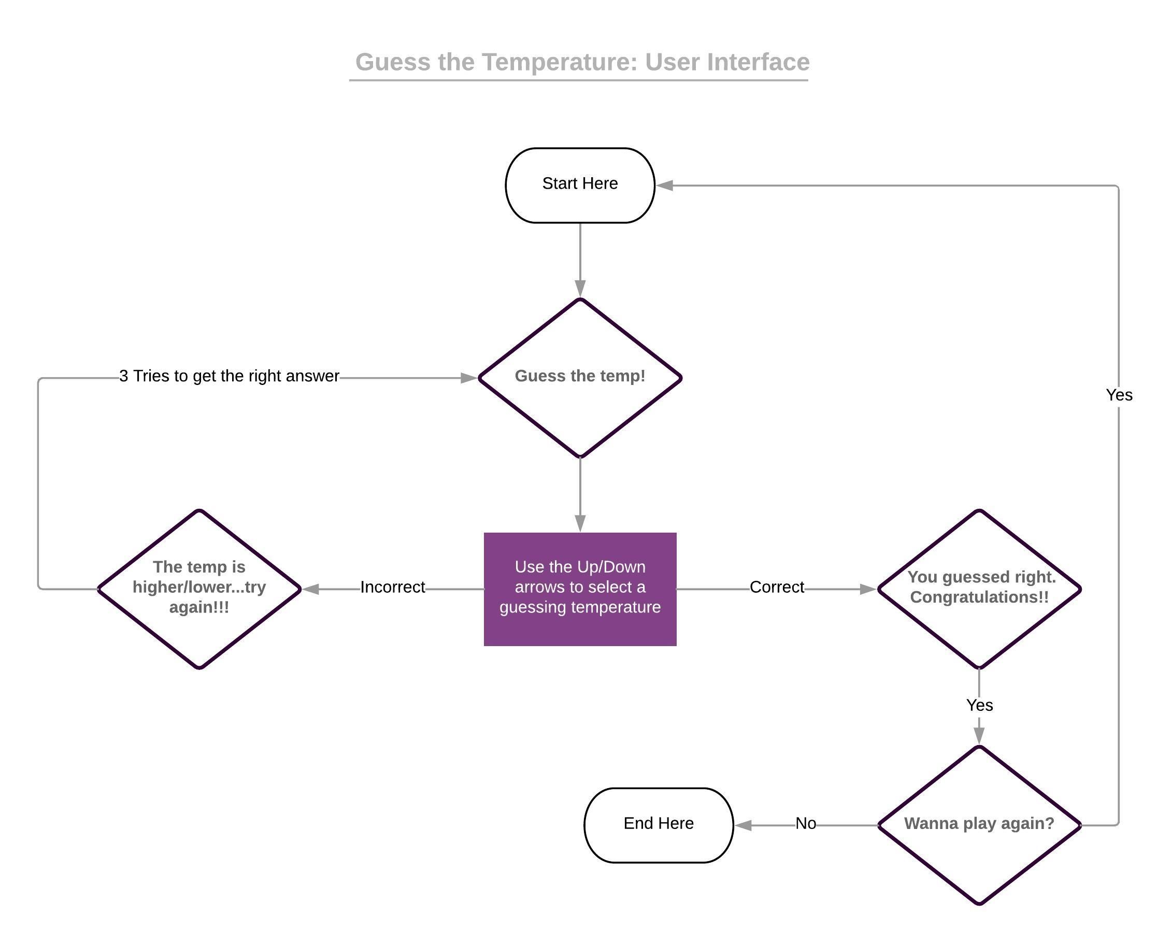

**Figure 2**: Game's User Interface Flowchart

**Aim 3: To teach the importance of correct sensor selection and technology advancement for temperature measurements to the public**

After each round of the game, asking post-game questions can help determine their thoughts on the guessing game. Questions that could be ask will be about the player’s initial thoughts about the game, such as how easy they feel guessing will be and how accurate they believe the temperature sensor to be, the player’s afterthoughts about the game, such as how they did relative to their predicted performance and if they believe their guesses weren’t correct due to the accuracy of the temperature sensor. Our group will discuss the accuracies of different sensors, including the sensor that was used in the game and what they are all generally used for/in and why.

1. **Discussion (0.5- 1 pages)**

We expect the game to work smoothly, for the circuit to accurately show the temperature of anything touching the thermistor as best as it can, and for the user interface to be free of errors through the Arduino Keypad LCD Shield. If we had more time to work on this in the future, we could increase the game by expanding it. As mentioned before, difficulty levels could be added and be based off the different temperature sensors and their accuracies which would make the margin of error smaller when guessing the temperature. With a more complex user interface, player statistics could be calculated the more they play the game. Rankings can be done through a scoring system and the player’s overall percentage of accuracy when guessing correctly. A timer could be added to include a speed round version of the game and could allow the opportunity to include a multiplayer version of the game, seeing which player can guess the temperature of the object the fastest while being as accurate as possible.

Simulations could be added so it could benefit training those in the culinary and healthcare industries. Culinary wise, the game could be centered around guessing temperature of different types of meat and then determine if they are raw or edible and, in some cases, how well done they are based off tenderness and temperature. It could also help with correctly cooking food with the correct amount of heat on the stove or grill to reduce the chance of overcooking and burning the food. In terms of the healthcare field, the game can help train medical students to read temperature of patients well enough to know if they have a fever or not. This could eventually help lead to other diagnoses for patients that are affected by body temperature.

1. **References (do not count in the page limit)**

1. “Temperature Sensors.” *Basic Electronics Tutorials*, www.electronics-tutorials.ws/io/io_3.html.

2. “4 Most Common Types of Temperature Sensor.” *Ametherm*, 27 Aug. 2018, www.ametherm.com/blog/thermistors/temperature-sensor-types.

3. “Improving the Accuracy of Temperature Measurements.” *Pico Technology*, www.picotech.com/library/application-note/improving-the-accuracy-of-temperature-measurements#thermistors.